**Schedule H1 Report**

“Schedule H1 Report” gives the list of Schedule H1 drugs used in Pharma Purchases and Pharma Sales.

1. Select “Schedule H1 Report” Menu Path :-Reports-> Pharma Retails Reports--> Schedule H1.

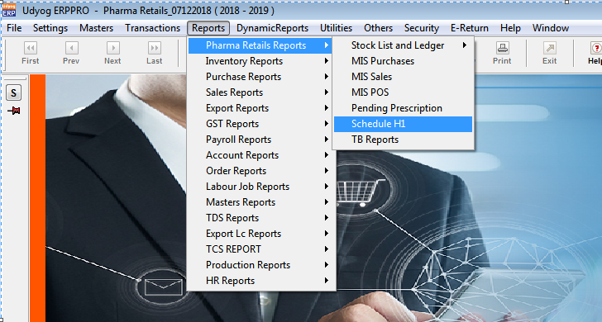

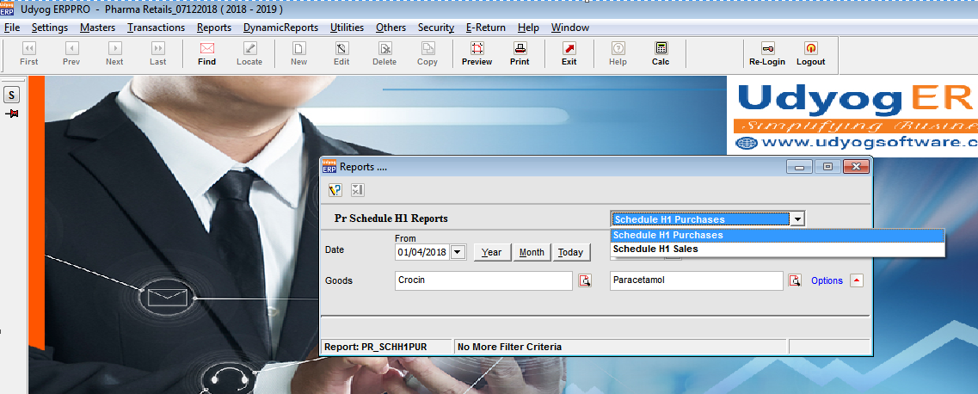

1. Created below 1 Generic Drug of Schedule H1 type :

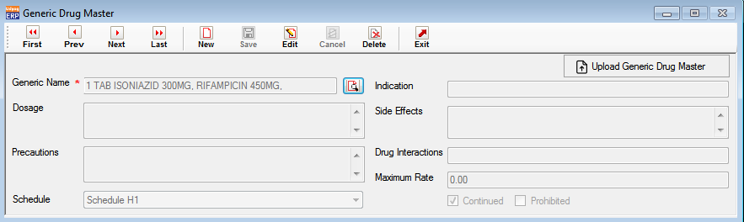

1. Created below 2 medicines of the above generic drug :

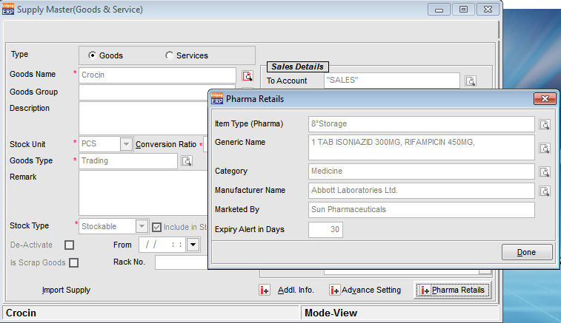

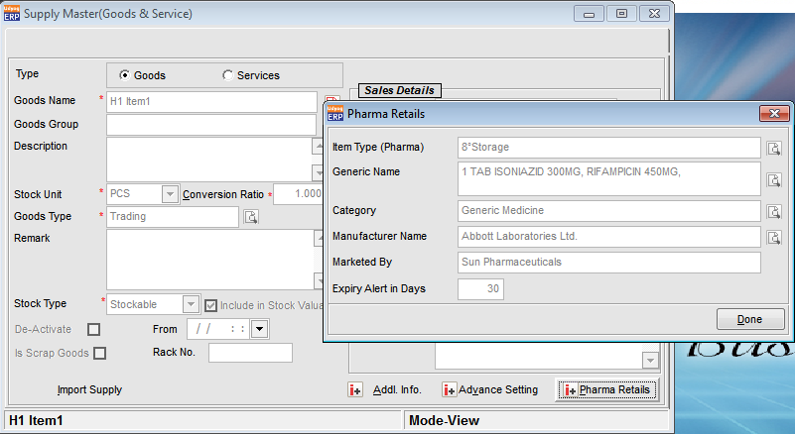

1. Created below 2 Purchases for the above 2 medicines :

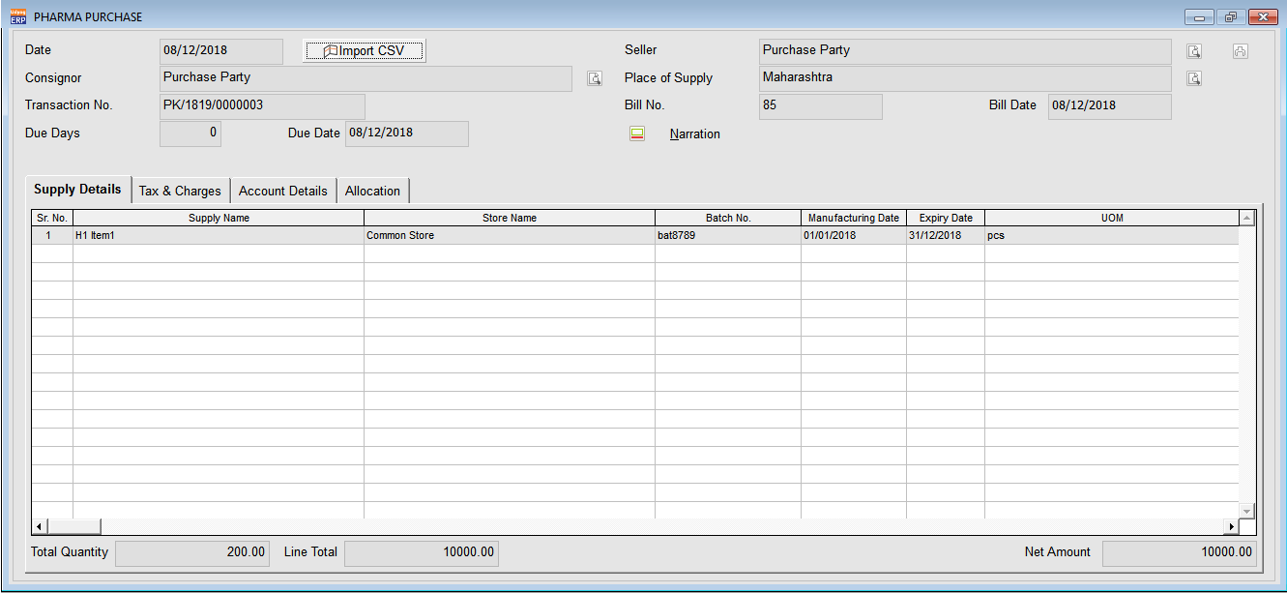

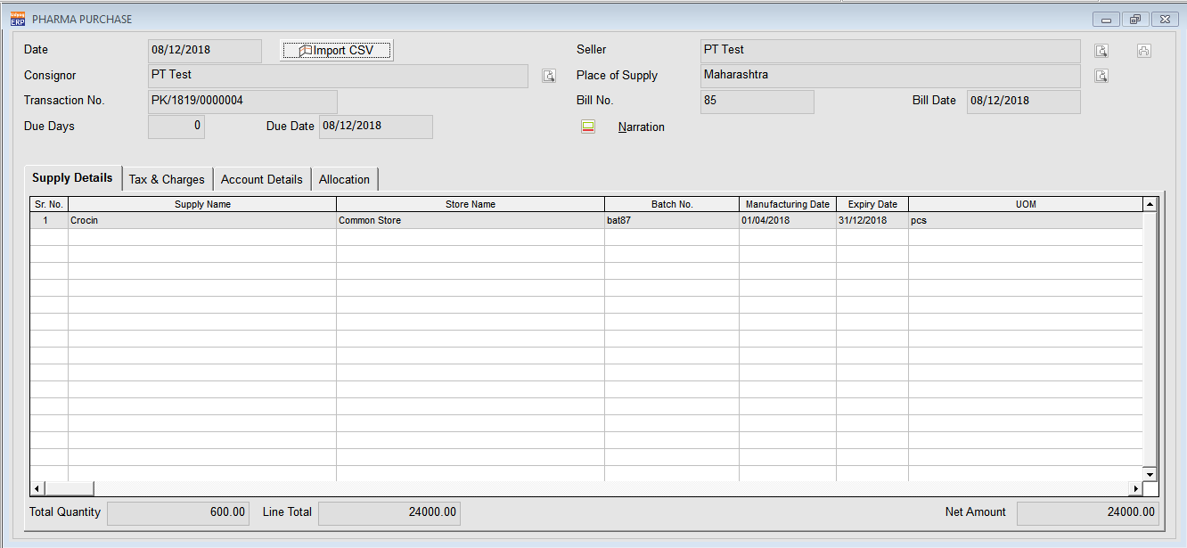

1. Below is the Schedule H1 report for the above 2 Purchases :

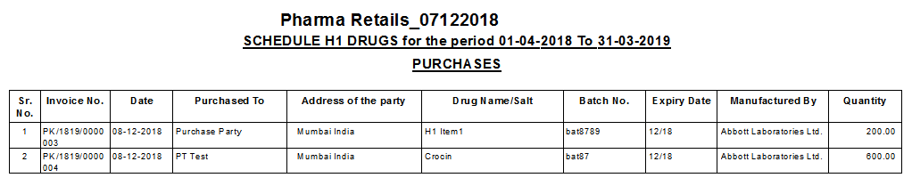

1. Created below Pharma POS :

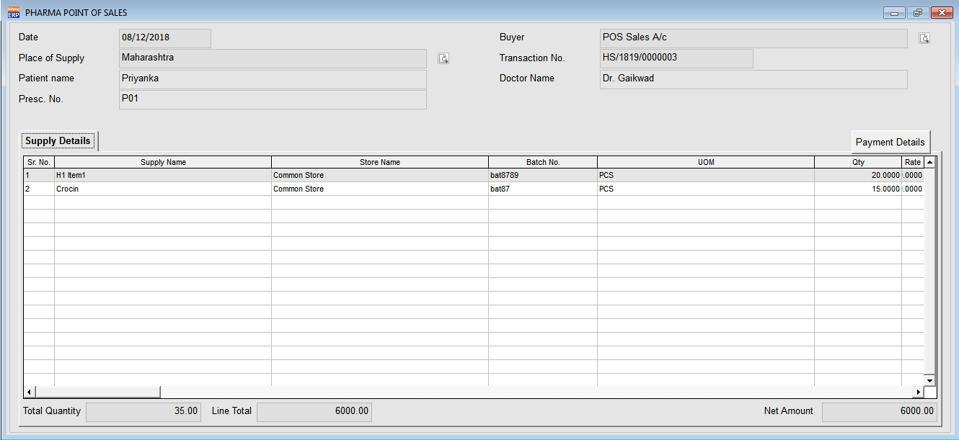

1. Below entry is the Pharma Sales with pickup of Pharma POS :

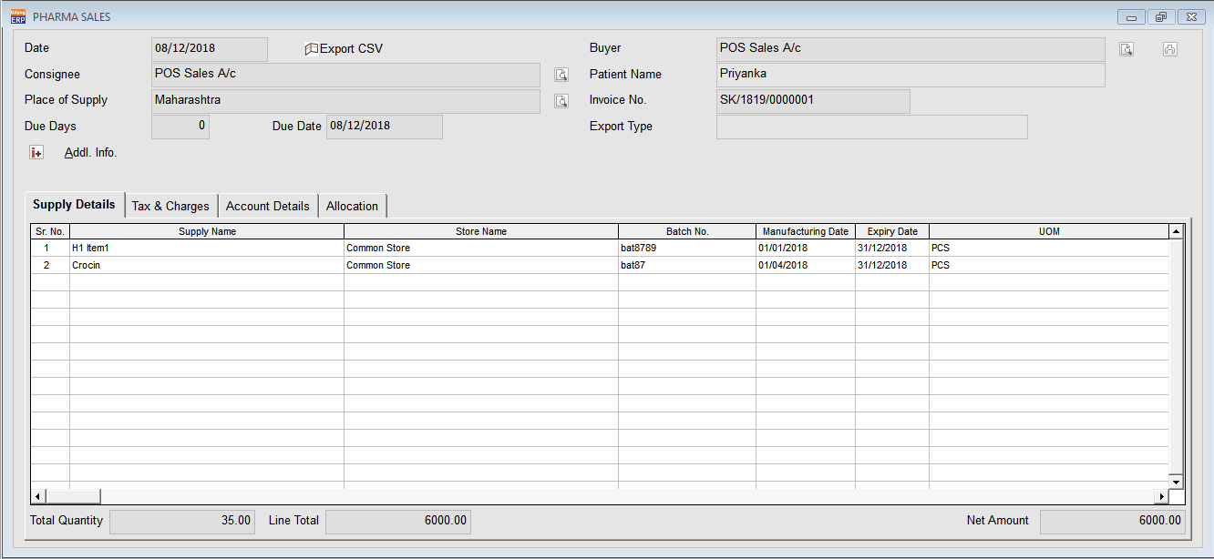

1. Below is the Pharma Sales without pickup of Pharma POS :

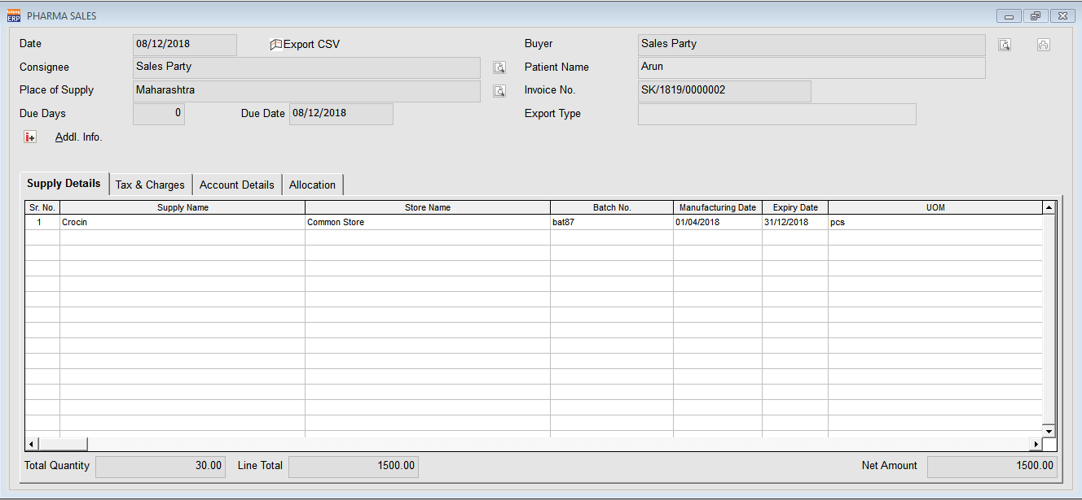

1. Below is the Schedule H1 report for the above 2 Sales :

